BBB SOCIETY: SAVE-A-HEAD SCRIPT, 2018

Exhibit Name: Save-a-head
Average number of volunteers needed: ­­­2-3

Materials:
- Pink play-doh
- Brain molds
- Saran wrap
- Aluminum foil
- Styrofoam cups
- Masking/duct tape

TO MAKE THE BRAINS:
- Have kids make the brains using play-doh and brain molds
- Wrap their play-doh brains in THREE layers of saran wrap (meninges)
- Then wrap brains in aluminum foil (skull)
- Helmet group: Half of the kids will place their skulls in a styrofoam cup “helmet” and use masking tape to secure the helmet on the head

Guidelines for the exhibit presentation (ie. Important concepts to cover or a script):

SCRIPT: Introduce ourselves

Person 1: Hi guys! We’re here today to talk to you about brain injury. Since the brain is the most important part of our body, it is important to keep it safe at all times. If our brains get hurt, we may get headaches, just like we might get aches from injuring any other parts of our body. However, because the brain has so many special functions, injuring our heads can also affect our memory, our ability to concentrate, and so many other things. That’s why avoiding brain trauma is so important. Now, who knows how to ride a bike? [kids raise hands]

Person 2: Great! Who knows how to roller skate or rollerblade? [kids raise hands] Okay, what about skateboarding? [again, hands raise]

Person 3: Who can tell me what is the most important thing to wear when you’re bike riding, roller skating, or skateboarding? [call on student to reply. If no reply given, prompt by giving hint i.e. “it goes on your head”]

Person 4: Right! A helmet. Now does anyone know why it’s important to wear a helmet?

Person 5: It may seem obvious that you need to wear a helmet, but we’re going to show just how important it really is.

Person 1: As you have (or will) learn today, the brain is really specialized and each of the different parts of the brain do different things.

Person 2: Who can name some of things that your brain helps you do?

Person 1: So can everyone point to their brain? Thats right, it’s in your head. What does the brain look like? Is it smooth? It it spikey? Is it bumpy or flat?

Person 2: Yeah, it has grooves and ridges on it! These grooves and ridges on the outside of your brain are called sulci and gyri, and they store valuable information. Can everybody say “sulci”? Now, “gyri”! Now, can you take a guess for what else is inside our heads?

Person 3: Surrounding our brains are three layers of membrane that envelop and protect the brain. These layers are called the “meninges.” Can everyone say “meninges”?

Person 4: Okay, so inside of our head we have the brain and the three protective meninges layers surrounding the brain. Just the brain and its protective layer - like having a case for a phone. What comes after that?

Person 5: Your skull! Your skull is a hard bony structure that acts as another form of protection against brain injury. So let’s do a little recap. Does anyone remember what surrounds your brain? [let students answer] Great! What is on the outside of the meninges? [let students answer]

Person 1: All of the parts of your head help protect your brain, keeping those valuable grooves and ridges safe, so that your brain keeps functioning properly. Who remembers what those grooves and ridges are called? (Ask for sulci and gyri).

Person 2: But sometimes, your brain needs extra protection. For example, when you’re riding your bike quickly down the street. If you fall down on the hard cement when you’re riding your bike, you can injure your brain. When this happens, your brain actually changes shape! This can ruin your brain forever.

Your helmet protects your brain from getting hurt in case you fall down. It helps prevent your brain from changing shape when it hits the ground. Today we’re going to show you what happens when you wear a helmet and what happens if you don’t wear a helmet.

Person 1: Okay, I think we’re ready to begin our experiment!
- For our test, we’re going to use these cool molds to make our very own brains [hold up mold]. We also have some pink play-doh over here. What do you think that represents? [let students answer-- the brain] So we’re going to make our brain molds by pressing in the play-doh into the molds. (have kids do this). Good job everybody!
- Does anybody remember what the membranous layers that surround our brain are called? [let students answer -- meninges]. Great! How many layers of meninges are there? [answer: three!] This plastic wrap is going to represent our three layers of protective meninges.
- Next, we’ll wrap the brains in aluminum foil. Who can tell us what the aluminum foil represents? [let students answer-- it represents the skull]

Person 2: Let’s divide up into two teams to test our models: we’ll have Team Helmet and Team No Helmet. [divide group into two; one group will be the Helmet group, and the other group will be the no Helmet group.]

- Ok, Team Helmet, you guys are safety superstars! Today, you get to protect your brains with helmets [hold up styrofoam cup and help them secure their brain in the helmet with tape].

Person 3: Now, when we say “go” each group will drop their brains. Who can predict what will happen when the brains drop? Do we think the protected brains will look the same as the unprotected brains? [have students answer].

Person 4: Ok now let’s finally run our experiment…. READY-- SET-- GO!!

[kids drop the brains]

Person 1: Alright, now for our big reveal!! [VOLUNTEERS: one of us will unwrap the protected brain, and the other will unwrap the unprotected brain]

Person 2: It looks like our prediction was right! The unprotected brain was more damaged than the protected brain. That means the helmet worked!

Person 3: So you see, even though your body has lots of layers to protect your brain, you still need a helmet to make sure you keep your brain safe!

Person 4: Well, it turns out that if you get hurt, where you hurt your brain will affect what may happen to you. [Point to poster] if you hurt the front part of your brain, you might have problems with language, you might have trouble talking, making decisions, or moving.

Person 5: If you hurt the back part of your brain [point to poster], this may cause you to have trouble seeing. And if you hurt the bottom part of your brain (temporal lobe) you may have trouble hearing or remembering things.

Person 1: So it looks like you don’t want to hurt ANY part of your brain because they all are pretty important and affect more than just your head. If you stub your toe, only your toe will to hurt. But if you hit your head, you may have trouble with several different parts of your body. Does anyone have any questions?

Person 2: Okay, so let’s recap again to see what we can remember! Who remembers what the grooves and ridges on our brain are called? Who remembers what the three layers of protective membrane surrounding the brain are called? Who remembers what hard, bony structure protects our brain?

Person 3: [recaps lobe-specific injuries]
[wrap-up, answer questions]

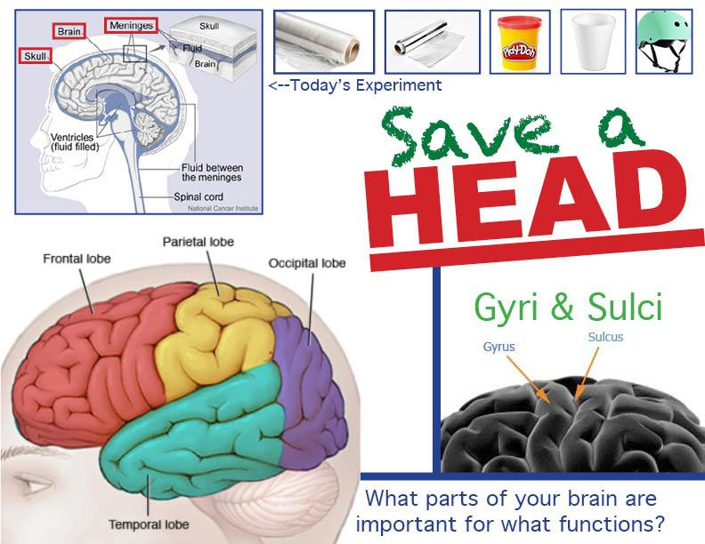
Poster

